CURRICULUM VITAE

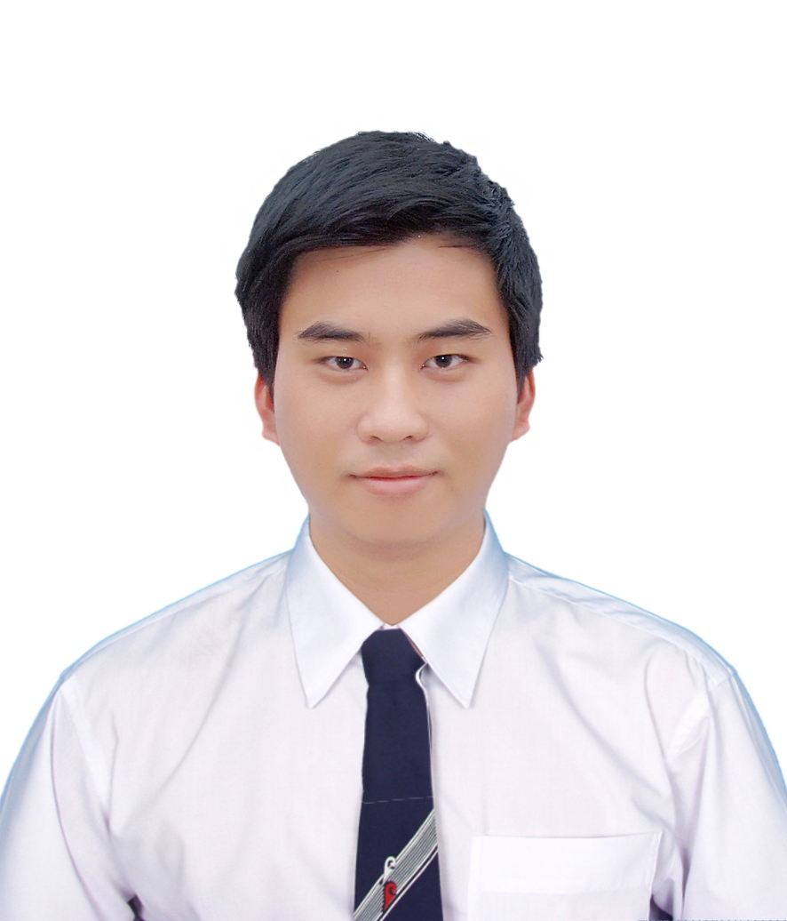

|  |  |
| --- | --- |
| PERSONAL DETAILS | |
| Name | **Nguyen Duy Hoang** |
| Date of birth | April 5th 1991 |
| Sex | Male |
| Address: | 163/14/32R To Hien Thanh, ward 13, district 10, Ho Chi Minh City  Vietnam |
| Tel: | 0122.975.0414 |
| Mobile | 0122.975.0414 |
| Email | hoanggeneral@gmail.com |
| Marital status | Single |
|  |  |
| EDUCATION BACKGROUND | |
| 2006-2009 | Thong Nhat A high school, Trang Bom, Dong Nai |
| 2009-2014 | Ho Chi Minh University of Technology  Bachelor of engineering (Mechatronics engineering )  Grade Point Average : 7.50 |
|  |  |
| WORKING EXPERIENCE | |
| 2011 | Private tutor of a student grade 8th |
| 2014 | Private tutor of two student grade 12nd |
|  |  |
|  |  |
| KEY SKILLS | |
| Communication skills | With the experience at works such as organizing outside activities, it also taught me the importance of listening, supporting and respecting the others. |
| Computer skill | MS Word, Excel, Access, Power Point, Window, Email, Internet |
| Graphic design skill | Autocad 2D, SolidWorks, Unigraphic NX7.0 |
| Controlling skill | Micro controller PIC, Arduino, PLC Misubishi, Omron. |
| Mechanical skill | Turing, milling, planning (level beginner). |
| Language skill | English: Reading and writing well  Speaking and listening cleverly.  TOEIC 470  Japanese: level beginner |
| Sport skill | Football (defend position), volleyball, badminton and chess |

|  |  |
| --- | --- |
| ACTIVITIES |  |
|  | Take part in some events such as:  -Supporting students during entering University examination 2011  -Green Summer 2012. (supporting Dong Thap people make roads or bridges)  -Reporting in Proceedings of The 4th Symposium on Mechanical Engineering for Young Scientist. |
| ACHIEVEMENT |  |
|  | I have 7 scholarships during University's time.  I have an article about science of Proceedings of The 4th Symposium on Mechanical Engineering for Young Scientist. |
|  |  |
| PERSONAL QUALITIES | |
|  | Sense of humor, sense of responsibility, carefulness in all the works done are my greatest strengths. |
|  |  |
| HOBBIES |  |
|  | Listening traditional music, Trinh Cong Son music; reading romantic novel and cooking. |
|  |  |
| REFEREES |  |
|  | PhD Pham Cong Bang Head of Mechatronic Department HCMC University of Technology  Email: cbpham@hcmut.edu.vn |